**Step 1: Define Your Audience/Tone**

*20 minutes*  
Answer the following questions in a .doc file:

* Who will visit your site? Potential employers & new clients or customers looking to grow their online business.
* What can make you and/or your product stand out against your competitors? We are a full service branding and marketing agency. Which offers convenience for small businesses looking for a consistent brand image and go-to-market digital strategy.
* How would you speak to your clientele if you were communicating in person? How could you translate that style and tone digitally? I would explain everything like a 5 year old since most small businesses owners don’t know the firs thing about digital marketing.
* What colors represent you or your product? Red to excite the company into action and taking charge.
* What images illustrate your message?



image source: unsplash



image source: unsplash



image source: unsplash

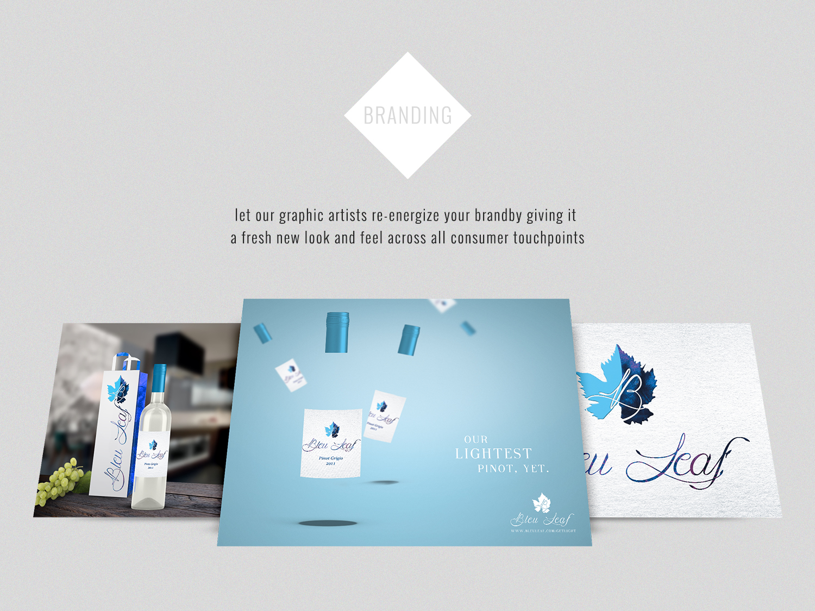

photo made by me

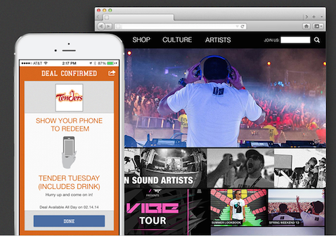

photo made by me

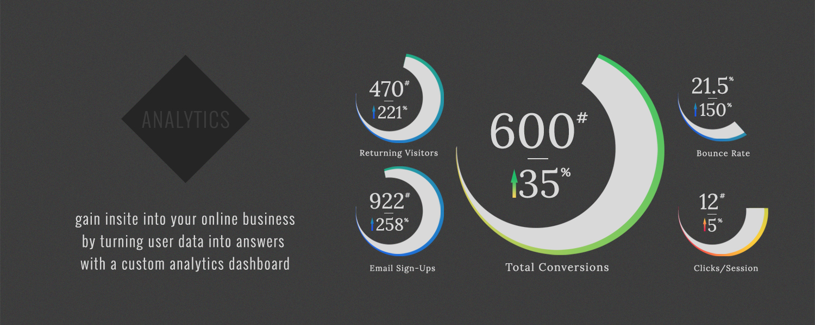

photo made by me

**Step 2: Identify Content**

*20 minutes*  
Create a sitemap in outline format of your website in the same .doc file. Use the following questions as a guide:

* What are the three-to-five pages titled?
  + Homepage
  + About
  + Portfolio
  + Contact
  + Blog
* What will be the purpose for each?
  1. Homepage
     1. About (to educate on our main value prop and briefly qualify web visitors)
        1. At Brodie Creative, we have a different approach to creativity. We believe design should be more than beautiful. It should also be functional. This means leveraging information to create beautifully functional designs that maximize brand engagement resulting in long-term brand success.
           1. Services (to educate on our service offerings and how these services can help each business)

Service List Complete List of Services

Branding

“Let our graphic artists re-energize your brand by giving it a fresh new look and feel across all consumer touchpoints.”

Analytics

“Gain insight into your online business by turning user data into answers with a custom analytics dashboard.”

Adwords

“Drive qualified traffic to your online site with any size monthly budget to increase brand awareness and sales.”

Social

“Get your product or service trending on social media by creating lasting relationships with social influencers around the globe.”

UX

“Engage users while making your website or app more navigable for the user. This results in more return visits and repeat purchases.”

UI

“Switch to high-conversion, easy-to-use interfaces for your website, mobile app or digital loyalty program.”

Development

“Let our reliable web & app developers code custom websites, mobile apps and programs that meet your businesses’ needs.”

Testimonials (to build trust with potential clients & feature current clients)

Clients (logo pics to build trust with potential clients)

Campus Foodz

Mingos

Kings

Cody Ellsworth Racing

Diamond Vendors

Sparians

Orbit Racing

Lost In Sound

GVC

Image Athletic

Bleu Leaf

* 1. Portfolio (a show-and-tell type format for people are looking to see first hand what we’ve created for our clients)
     1. “Here are some projects that we’ve worked on recently, feel free to browse by client or sort them by type.”
        1. Projects listed masonry style by client
        2. Sort by project type feature?
        3. Click on client intro photo and go to page with gallery bullet list of services performed?
  2. Contact (once people know what we offer, trust us and want our services, they’ll become ‘qualified leads’ and we can ask them to reach out to us).
     1. “We love hearing from new people, drop us a line and let’s get to work already.”
        1. Store locations (Virual office for Google maps and local SEO)
        2. Departments with contact info (so people know which department to call)
        3. ‘Start Your Project’ form (to better qualify incoming leads)
  3. Blog (SEO purposes and return visits)
* What should each page contain? Will there be textual content? Or just images?
  + Each pages contains images and text content

## Step 3: Create a logo

30 minutes  
Based on the perception you want to create for your brand, design three variations of your logo. Your logo could be an image, a symbol, a wordmark, or a stylized version of your page name. Save the logo as a .png file.

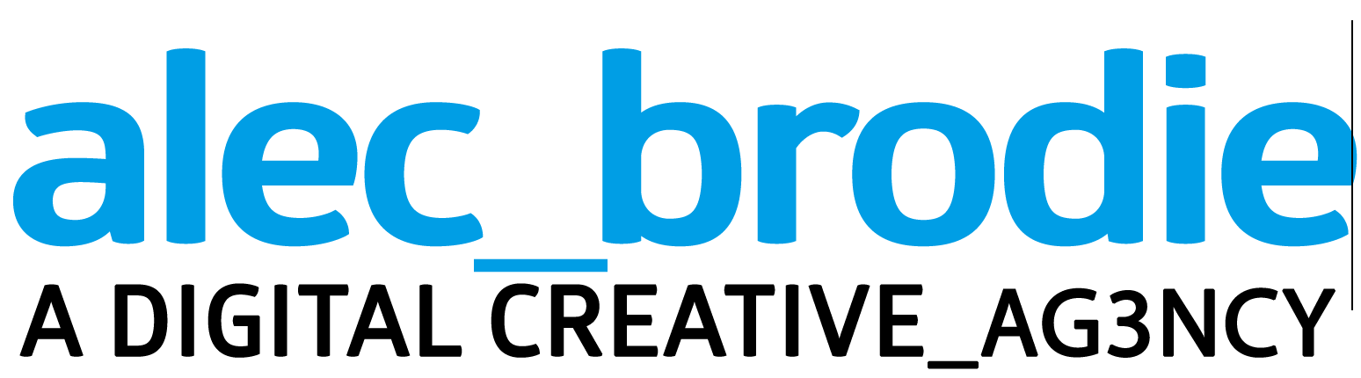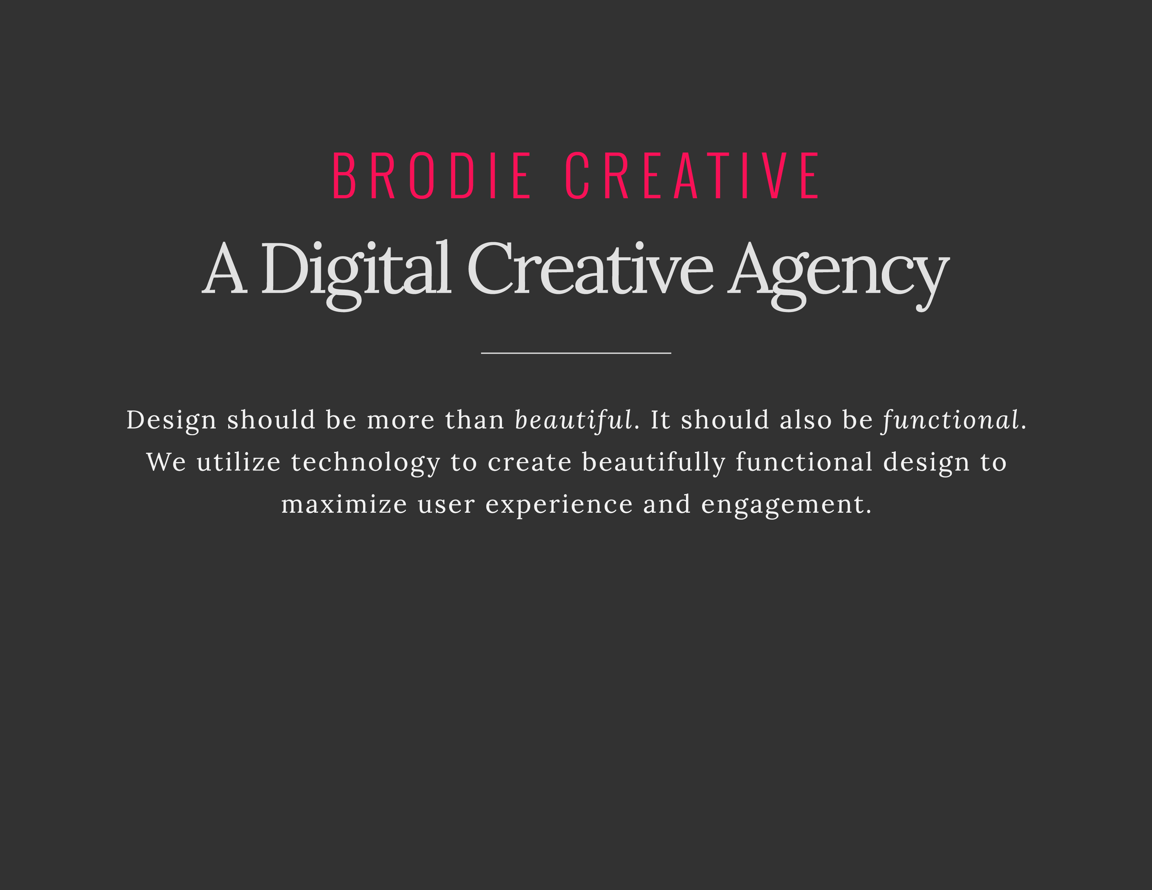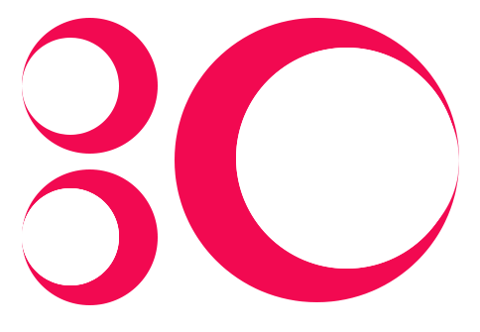

## Step 4: Create a style guide

30 minutes  
Using design software, experiment with different fonts and styles you’d like to use. Keep in mind the fundamentals of typography and visual design, such as hierarchy and contrast.

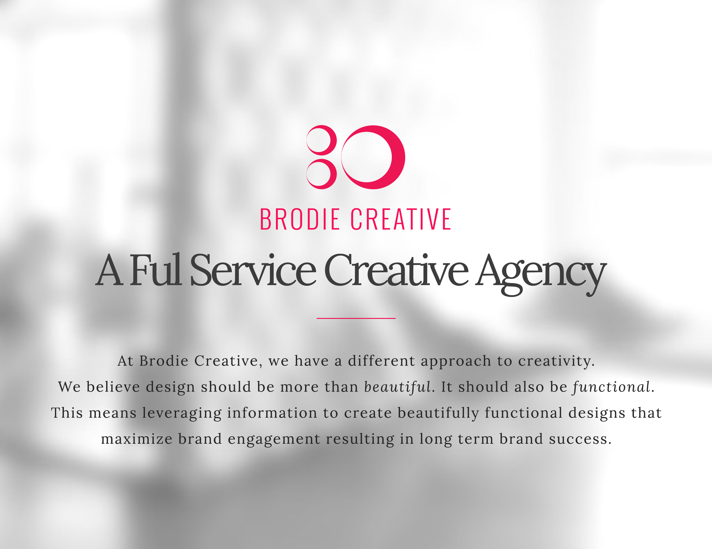

## Step 5: Create/Update sketches

*20-30 minutes*  
Using primitives, i.e. lines and basic shapes, create or update a series of thumbnail sketches for your project. Make sure the sketches demonstrate focal point, hierarchy, and balance across different grid-based layouts.

Remember to incorporate boxes for your nav, header, footer, and body.